1. 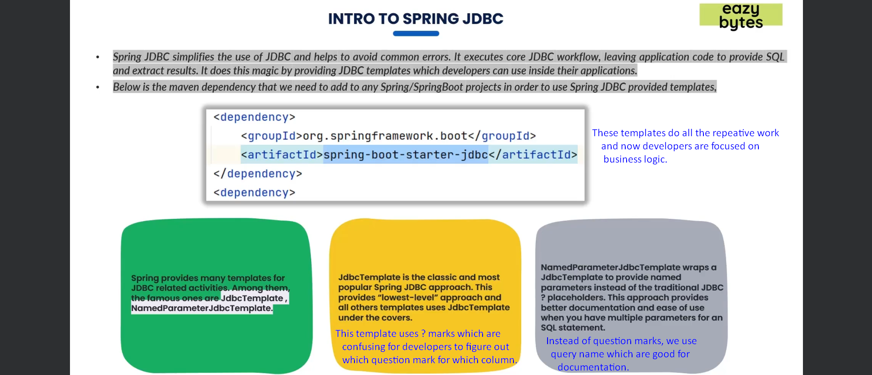
2. 
3. **NOTE**: There are much better frameworks than Spring JDBC like Spring JPA, Hibernate but there are still apps out in the market using Spring JDBC.   
   It is because it is much better to use Spring JDBC if your app has very limited number of tables.
4. **NOTE**: Spring JPA, hibernates are heavy framework.